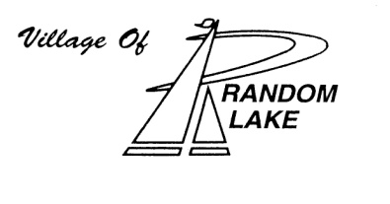
Resident
Agreement for Rental
LAKEVIEW PARK PAVILION
Random Lake, Wisconsin

It is hereby agreed that for the payment of $50.00 rental fee and $50.00 facilities retaining fee from _________________________(renter) shall be entitled to exclusive use of the Lakeview Park Pavilion and four (4) picnic tables on ____________________ (date). This does not include exclusive use of the restroom portion of the building.
The rental period shall end at 9:00 P.M. One check of $100 made out to the Village of Random Lake must accompany this signed agreement for pavilion to be reserved in your name.
A $50.00 retaining fee will be returned to the Renter, if clean up is not required by the Parks Department. The Renter also agrees to dispose of trash and recyclables properly prior to vacating the pavilion and to abide by the rules noted in the pavilion rental policy.
Per Village of Random Lake Municipal Code Section 26-1, Renter is subject to a fine if any damage is done to the pavilion. Renter also agrees that repair costs for any damage done to the pavilion during renter’s occupancy shall be the sole responsibility of the renter.

Parking Fee: $5.00 per vehicle when an attendant is present

Printed Name: _____________________________________________
Address: _____________________________________________
City, State, Zip Code: _____________________________________________
Telephone Number: ( ) _______________________________________

Signatures:

______________________________ ______________________________ _____________
Clerk/Treasurer Signature of Renter Date
Village of Random Lake

Payment/Security Deposit: $ 100.00 Check #: __________

Return a check in the amount of $100.00 along with signed Agreement to the address listed below.

